**Chapter** **2**

**SOFTWARE REQUIREMENT ANALYSIS**

* 1. **Feasibility Study**

The project “CapStore” is technically feasible as it uses java as its back end and JSP and html using bootstrap as front-end operations which is readily available and easy to use.

Drawing on research findings and best practice, provide an overview of the national perspective relating to the value of online shopping system at the time of commission, in the context of contributing to reducing time and recommend whether the service should continue to form part of the client’s core business.

Evaluate the strengths and weaknesses of the service by examining in – house, working practices, reports and other documentation and project sponsors.

Based on evaluation findings and in consideration of the aims of the service, make recommendations on opportunities for income generation from provision of CapStore monitoring services to other agencies and expansion of the service generally based on future service charging of tenants and leaseholders.

Whether a project is viable or not, i.e. whether it can generate an equal or a higher rate of return during its lifetime requires a thorough investigation of the investment per se as well as the level of current expenditure. The preliminary design is the simple description of the conceived idea with an indication of the main factors to be considered in the study.

* 1. **Requirement Analysis**
     1. **Normal Requirements**

Normal requirements consist of objectives and goals that are stated during the meeting with the people.

**Normal requirements of our project are:**

1. User friendly efficient and lucrative system.
2. Minimum maintenance cost (may be graphics definition).
3. Availability of expected requirements within the mobile configuration.
4. Easy to operate.
5. They observe our application and the system as this is built with professional manner.
6. The system with measured python coding, professional thinking.
   * 1. **Expected Requirements**

These requirements are implicit to the system and may be so fundamental that the relevant people do not explicitly state them. Their absence will be a cause for dissatisfaction.

1. Develop system within limited cost.
2. Maximum high definition.
3. Minimum hardware requirements which is relevant for this online shopping system.
4. Design whole system with efficient manner.
   * 1. **Exciting Requirements**

These requirements are for features that go beyond the customer's expectations and prove to be very satisfying when present:

1. We may provide some more design for better layout in future.
2. Maximum high regulation with minimum hardware.
3. Easy to update application (if some new features come).
   * 1. **Functional Requirements**

The application needs a good internet connection to run smoothly.

* + 1. **Non- Functional Requirements**

**Performance:** The performance of this website highly depends upon the speed of the Internet.

**Reliability:** System is quite reliable.

**Availability:** The system shall be available all the time once the connection with database is established.

* + 1. **Hardware Interface**
  + Ram 2 GB
  + Processor Dual Core and above
  + Hard Drive 20 GB
    1. **Software Interface**
  + **Oracle Database** (commonly referred to as **Oracle RDBMS** or simply as **Oracle**) is a proprietary multi-model database[[4]](https://en.wikipedia.org/wiki/Oracle_Database#cite_note-4) management system produced and marketed by Oracle Corporation.
  + **Spring Boot:** It is a framework where project will run.
  + **Operating System:** Windows 8/8.1/10
  1. **System Modules**
     1. **Merchant Login**

The index page of the website contains common login through which any User can login. Merchant have to login if he/she wants to add new item or wants to remove any item. Merchant can’t skip this part of the website because all the details about the merchant is required.

* + 1. **Sign-up (New Merchant)**

There is a sign-up module for the new merchant one can get himself/herself authenticated by signing up and getting his/her account on this website. In this module, all the details of merchant is input which consists of name, email, password, contact, city, address. A merchant can login in the system after this module. The output of this module is homepage of the products

* 1. **Use Case Diagram**

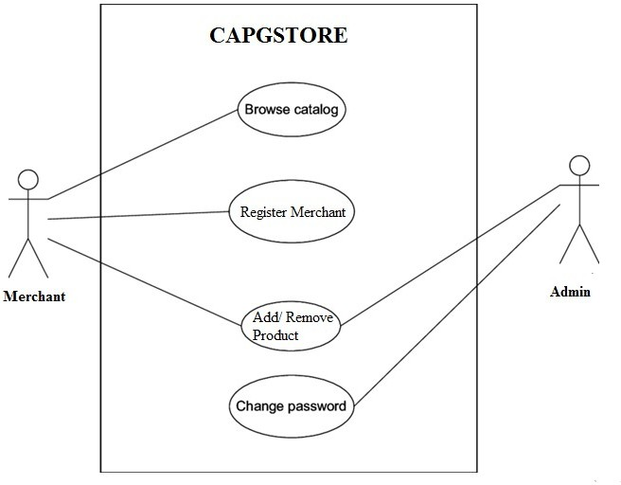 Figure 2.4.1 Use Case Diagram

* 1. **SRS**
     1. **Introduction**

E-commerce is fast gaining ground as an accepted and used business paradigm. More and more business houses are implementing web sites providing functionality for performing commercial transactions over the web. It is reasonable to say that the process of shopping on the web is becoming common place.

* + 1. **Purpose**

The objective of this project is to develop a general-purpose e-commerce store where any product (such as fashion items like shirts, jeans and trousers etc.) can be bought from the comfort of home through the Internet. However, for implementation purposes, this paper will deal with an online shopping store. An online store is a virtual store on the Internet where customers can browse the catalogue and select products of interest. The selected items may be collected in a shopping cart. At checkout time, the items in the shopping cart will be presented as an order. At that time, more information will be needed to complete the transaction. Usually, the customer will be asked to fill or select a billing address, a shipping address, a shipping option, and payment information such as credit card number. An e-mail notification is sent to the customer as soon as the order is placed.

* + 1. **Scope**

Electronic Commerce is more than just buying and selling products online. It also includes the entire online process of developing, marketing, selling, delivering, servicing and paying for products and services. India has shown tremendous growth in the E-commerce segment. With an internet user base of over 300 million, India has third largest internet population after US & China.

* + 1. **References**
  + The complete reference –HTML and CSS
  + The complete reference –Spring Boot
  + IEEE-Format
  + Software Development-For model designing
  + <https://www.tutorialspoint.com/jsp/>
  + <https://www.lucidchart.com/pages/data-flow-diagram/>
  + <https://www.w3schools.com/bootstrap/>
  + <https://www.tutorialspoint.com/javascript/>
  + <https://www.javatpoint.com/spring-boot-tutorial>
    1. **Overview**

The SRS contain use case diagram of the online shopping system named as CapStore; it also contains the Data Flow Diagram.